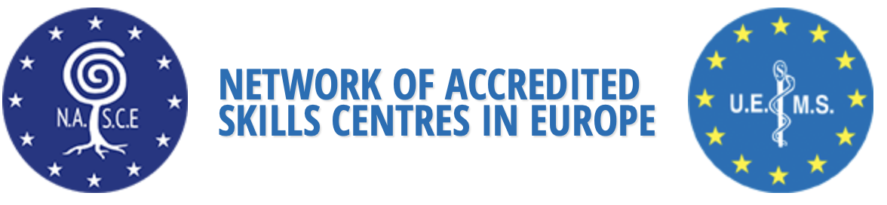

Dear Colleagues and NASCE enthusiasts,

The annual NASCE Scientific Meeting held in Athens, September 8th- 9th, organized by Professor Apostolos E. Papalois and Professor George C. Zografos, we wanted to give you a brief update.

The meeting was preceded by the train the trainer course, organized and facilitated by Dara O’Keeffe (RCSI), Dilek Kitapcioglu (CASE) and Ceclia Escher (CAMST). Thirty two participants from 9 European Countries participated and their feedback was overwhelming.

During the Meeting, 200 colleagues had registered and participated in person throughout the two days, and 251 attended virtually. A great success.

During the scientific meeting excellent keynotes were delivered by worldwide experts such as E. Aksoy (CASE), E. Georgiou (Athens), K. Izzetoglu (Philadelphia), P. Hoffmeyer (SFITS,Switzerland) and others, allowing participants to learn more about Serious Game Based Applications for Medical Training, Lessons learned about implementing and surveying simulation centers worldwide, and Optical Brain Imaging to Quantify Performance and Experience in Simulation Based training for Clinical skills,
Neuroscience and Leadership. Enclosed please find the final program, also available on the NASCE website.

For the first time an abstract competition took place, twelve abstract presenters participated and shared their innovative ideas or research throughout the meeting.

Third Prize – free registration to 7th Scientific Meeting in Nancy, France 12-13th October 2023.
M Ylönen, P Paajanen, T Kukkonen, P Torkki, J Paloneva, E Rosqvist
Multiprofessional in Situ Emergency Laparotomy Simulation Training Course in Ruptured Abdominal Aneurysm – Learning Outcomes, Costs And Real-Life Patient Outcomes

Second Prize – free registration to
Gilles Soenens, B Doyen, L Gordon, P Vlerick, F Vermasen, T Grantcharov, I Van Herzeele-
Assessing Endovascular Team Performances In The Hybrid Room Using A Comprehensive Data Capture Platform: Prospective Cohort Study

First Prize – free registration to Train the Trainer Course 10-11th October 2023, Nancy, France
G Soenens, J Lawaetz, AS Bamelis, LJ Nayahangan, L Konge, J Eiberg, I Van Herzeele
International Implementation of A Proficiency Based Stepwise Endovascular Curricular Training (Prospect) in Daily Practice

The official Accreditation Reviewing Board met, and surveyors have been appointed to visit
the Irish Centre for Applied Patient Safety and Simulation (ICAPSS) at the University of Galway, Galway, Ireland, who have applied for multidisciplinary NASCE accreditation.

We do hope welcoming you at the Train the Technician course 3-4th November 2022 in Istanbul, Turkey, at the business meeting 17th February 2023 in Brussels, Belgium and/or the 7th Annual Scientific NASCE meeting 12-13th October in Nancy, France preceded by the Train the Trainer course 10-11th October 2023.

Kind regards,

Emin Aksoy
President NASCE

Isabelle Van Herzeele
Chair NASCE ARB

Teuvo Antikanen
Treasurer NASCE

Apostolos E Papalois
Secretary NASCE

