Summary of NASCE Board or ARB member for the NASCE website

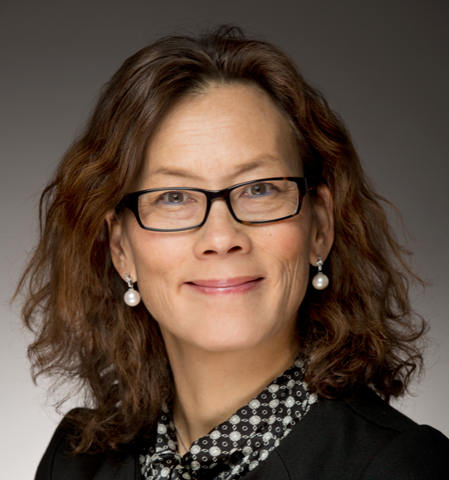

Name | Professor Li Felländer-Tsai MD, PhD
Specialty | Orthopaedic surgery
Special interst | Joint injuries
Affiliated training centre | Center for advanced medical simulation and training www.camst.se
Education and training | Karolinska Institutet
PhD | Yes, 1992
Hospital Appointment | Senior consultant Department of Orthopaedics Karolinska University Hospital, Stockholm, Sweden
Academic Appointment | Professor and Chair of the Division of Orthopaedics and Biotechnology, Department of Clinical Science Intervention and Technology, Karolinska Institutet, Stockholm, Sweden
Society Memberships | - President Swedish Orthopaedic Association (SOF)  - President Nordic Orthopaedic Federation (NOF)  - European Federation of National Associations of Orthopaedics and Traumatology (EFORT)  - Association of Bone and Joint Surgeons (ABJS)  - Royal Society of Medicne (RSM)  - American Academy of Orthopaedic Surgeons (AAOS)
Conflict(s) of interest | Consulting:  - NA
Research contracts
- Swedish Research Council
- Stockholm County Council
- Wallenberg Foundation
Stockholder of a healtchare company
- NA
Owner of a healthcare company
- NA
Other
- Board member Sophiahemmet

