eduroam - How visitors can connect when in Trinity

Visitors from participating institutions who want to use the eduroam service when in Trinity may follow the instructions provided below. The configuration instructions provided are meant to serve as a guideline only as implementation details for your home institution will determine the exact configuration steps to be taken.
Prior to visiting TCD you should:
- Confirm your home institution supports authentication from external institutions participating in the eduroam service - see the eduroam website
- Consult with your own institution’s eduroam documentation. Note that eduroam technical support must be provided by your home organisation and is not available from IT Services in TCD
- Consult the eduroam website for the most common configuration settings for a variety of mobile devices.
Please choose your operating system:
- Windows 10
- Windows 8
- Windows 7/Windows Vista
- Mac OS X
- iOS (iPhone/iPad)
- Android
- Windows Phone
- Other devices

How to configure Windows 8 or Windows 10 for eduroam
- Consult with your own institution's eduroam documentation before proceeding
- Once in Trinity, click the Network icon at the bottom right corner of the screen in the taskbar
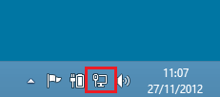
- Click the eduroam SSID and click Connect (check ‘Connect automatically’ if you wish)
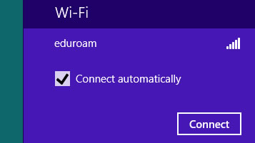
- Enter your credentials
User name: Enter your username in the following format - username@domain e.g. jbloggs@myuniversity.ie
Password: Enter your password
- You may receive the following certificate verification message, click Connect
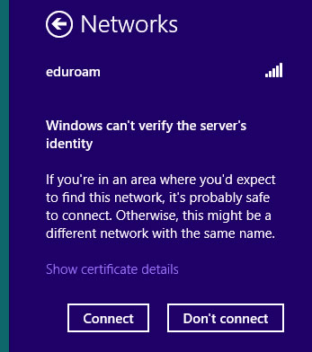

- You should now be connected to the eduroam network. If you are having problems please contact your home organisation as support for eduroam for visitors is not available from IT Services in Trinity.

- At any later point that you decide to no longer connect to eduroam then you should remove the eduroam network configuration settings.

