Summary of NASCE Board or ARB member
for the NASCE website

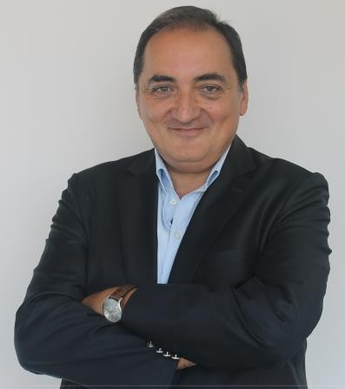

Name | Assoc.Professor M.Emin Aksoy MD, M.Sc, Ph.D.
Specialty | Family Medicine, Biomedical Engineering
Special interest | Medical Simulation, Serious Gaming, Optical Brain Imaging
Affiliated training centre | CASE (Center for Advanced Medical Simulation and Education) - Acıbadem  Mehmet Ali Aydinlar University, Istanbul Turkey
Education and training | Black Sea University, Istanbul Taksim Research and Training Hospital,  Institute of Biomedical Engineering - Bogazici University,
PhD | Biomedical Engineering
Hospital Appointment | -
Academic Appointment | Chair of Biomedical Device Technology Department, Acıbadem Mehmet Ali Aydinlar University, Istanbul Turkey  Director of CASE (Center for Advanced Medical Simulation and Education) - Acıbadem Mehmet Ali Aydinlar University, Istanbul Turkey
Society Memberships | - NASCE (Network of Accredited Skills Centers in Europe)  - SSIH (Society for Simulation in Healthcare)
Conflict(s) of interest | Consulting:  - NA
Research contracts
- The Scientific and Technological Research Council of Turkey
Stockholder of a healtchare company
- NA
Owner of a healthcare company
- NA
Other
- -

