Summary of NASCE Board or ARB member
for the NASCE website

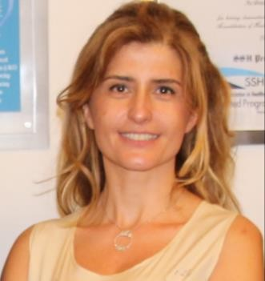

Name | Assist.Professor Dilek Kitapcioglu MD, Ph.D.
Specialty | Anaesthesiology & Intensive Care, Medical Education
Special interest | Medical Simulation, Curriculum Development, Program Evaluation
Affiliated training centre | CASE (Center for Advanced Medical Simulation and Education)
Education and training | Istanbul Cerrahpasa University, Istanbul Taksim Research and Training  Hospital, Marmara University.
PhD | Medical Education
Hospital Appointment | -
Academic Appointment | Medical Education Department, Acıbadem Mehmet Ali Aydinlar University, Istanbul Turkey  Vice Director of CASE (Center for Advanced Medical Simulation and Education)
Society Memberships | - NASCE (Network of Accredited Skills Centers in Europe)  - SSIH (Society for Simulation in Healthcare)
Conflict(s) of interest | Consulting:  - NA
Research contracts
- The Scientific and Technological Research Council of Turkey
Stockholder of a healtchare company
- NA
Owner of a healthcare company
- NA
Other
- -

