Summary of NASCE Board or ARB member for the NASCE website

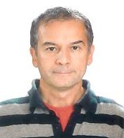

Name | Erhan Sayali
Specialty | Family Medicine
Special interst | Medical Simulation
Affiliated training centre | Acibadem University – CASE(Center of Advanced Simulation and Education)
Education and training | Medical Faculty, Family Medicine
PhD | -
Hospital Appointment | -
Academic Appointment | Instructor at Acibadem University
Society Memberships | - NASCE Member of ARB Committee  - Member of Turkish Medical Simulation Association  - SSIH(Society for Simulation in Healthcare) Membership  - Turkish Association of Family Physicians
Conflict(s) of interest | Consulting:  - NA
Research contracts
- NA
Stockholder of a healtchare company
- NA
Owner of a healthcare company
- NA
Other
- NA

