Summary of NASCE Board or ARB member for the NASCE website
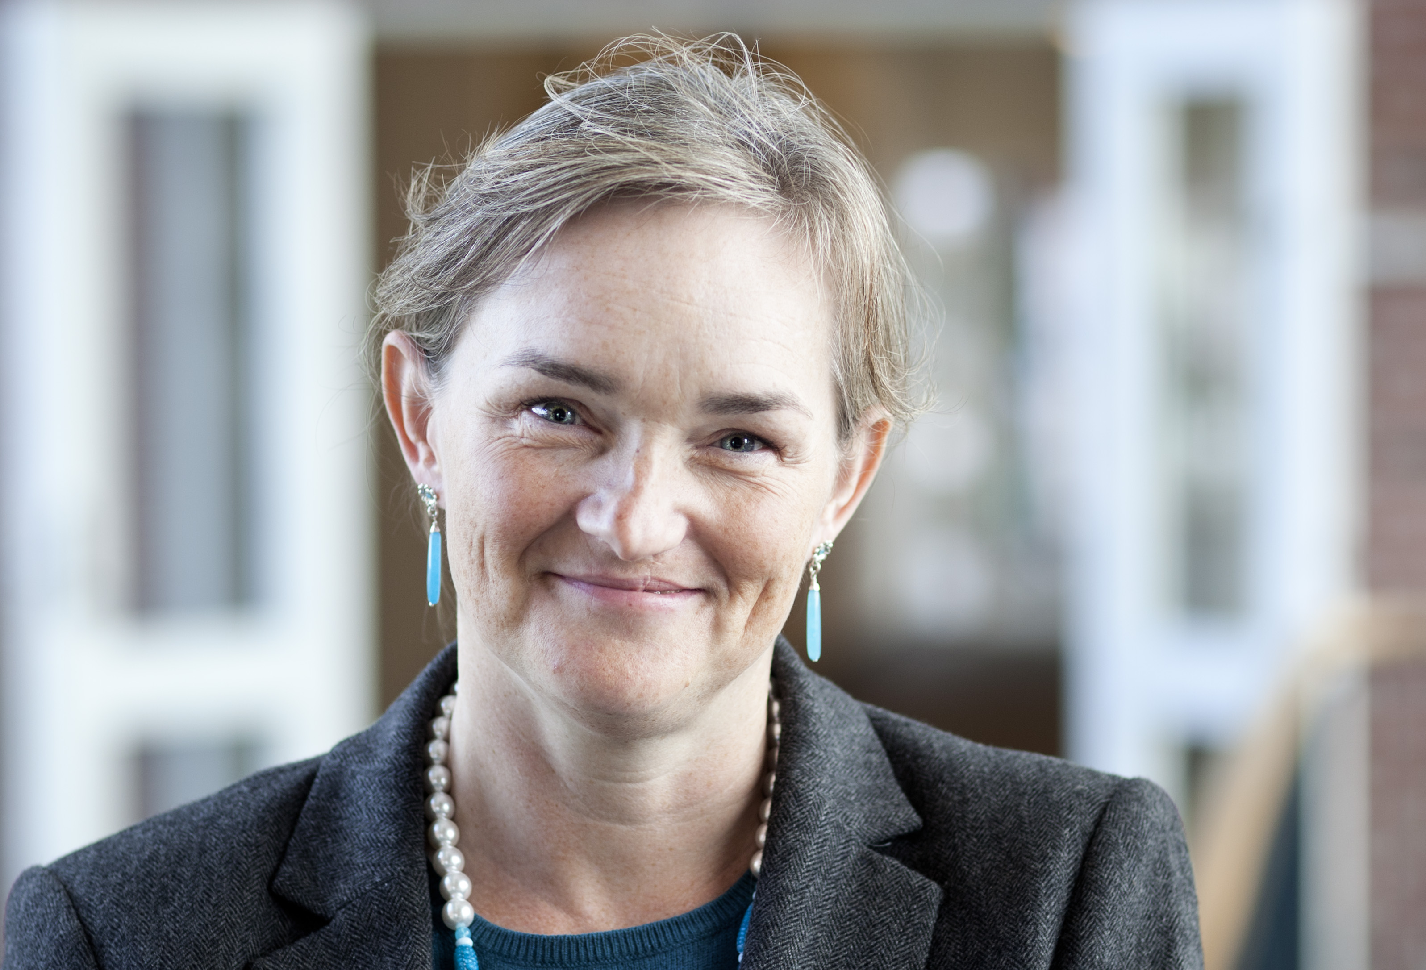

Name | Anne Mette Morcke
Specialty | Medical Education
Special interest(s) | Simulation-based learning
Affiliated training centre | Copenhagen Academy for Medical Education and Simulation (CAMES)
Education and training | MD
PhD | Health Sciences – Medical Education
Hospital Appointment | Centre for HR, The Capital Region of Denmark
Academic Appointment | Associate Professor, Department of Clinical Medicine, University of Copenhagen
Society Memberships | - NASCE Member of Executive Committee  - SSIH (Society for Simulation in Healthcare)  - AMEE (Association for Medical Education Europe)  - The Danish Medical Association
Conflict(s) of interest | Consulting: None
 | Research contracts: None
 | Stockholder of a healtchare company: NA
 | Owner of a healthcare company: NA
 | Other: NA

Bank Account (for internal use only)

