Summary of NASCE Board or ARB member for the NASCE website
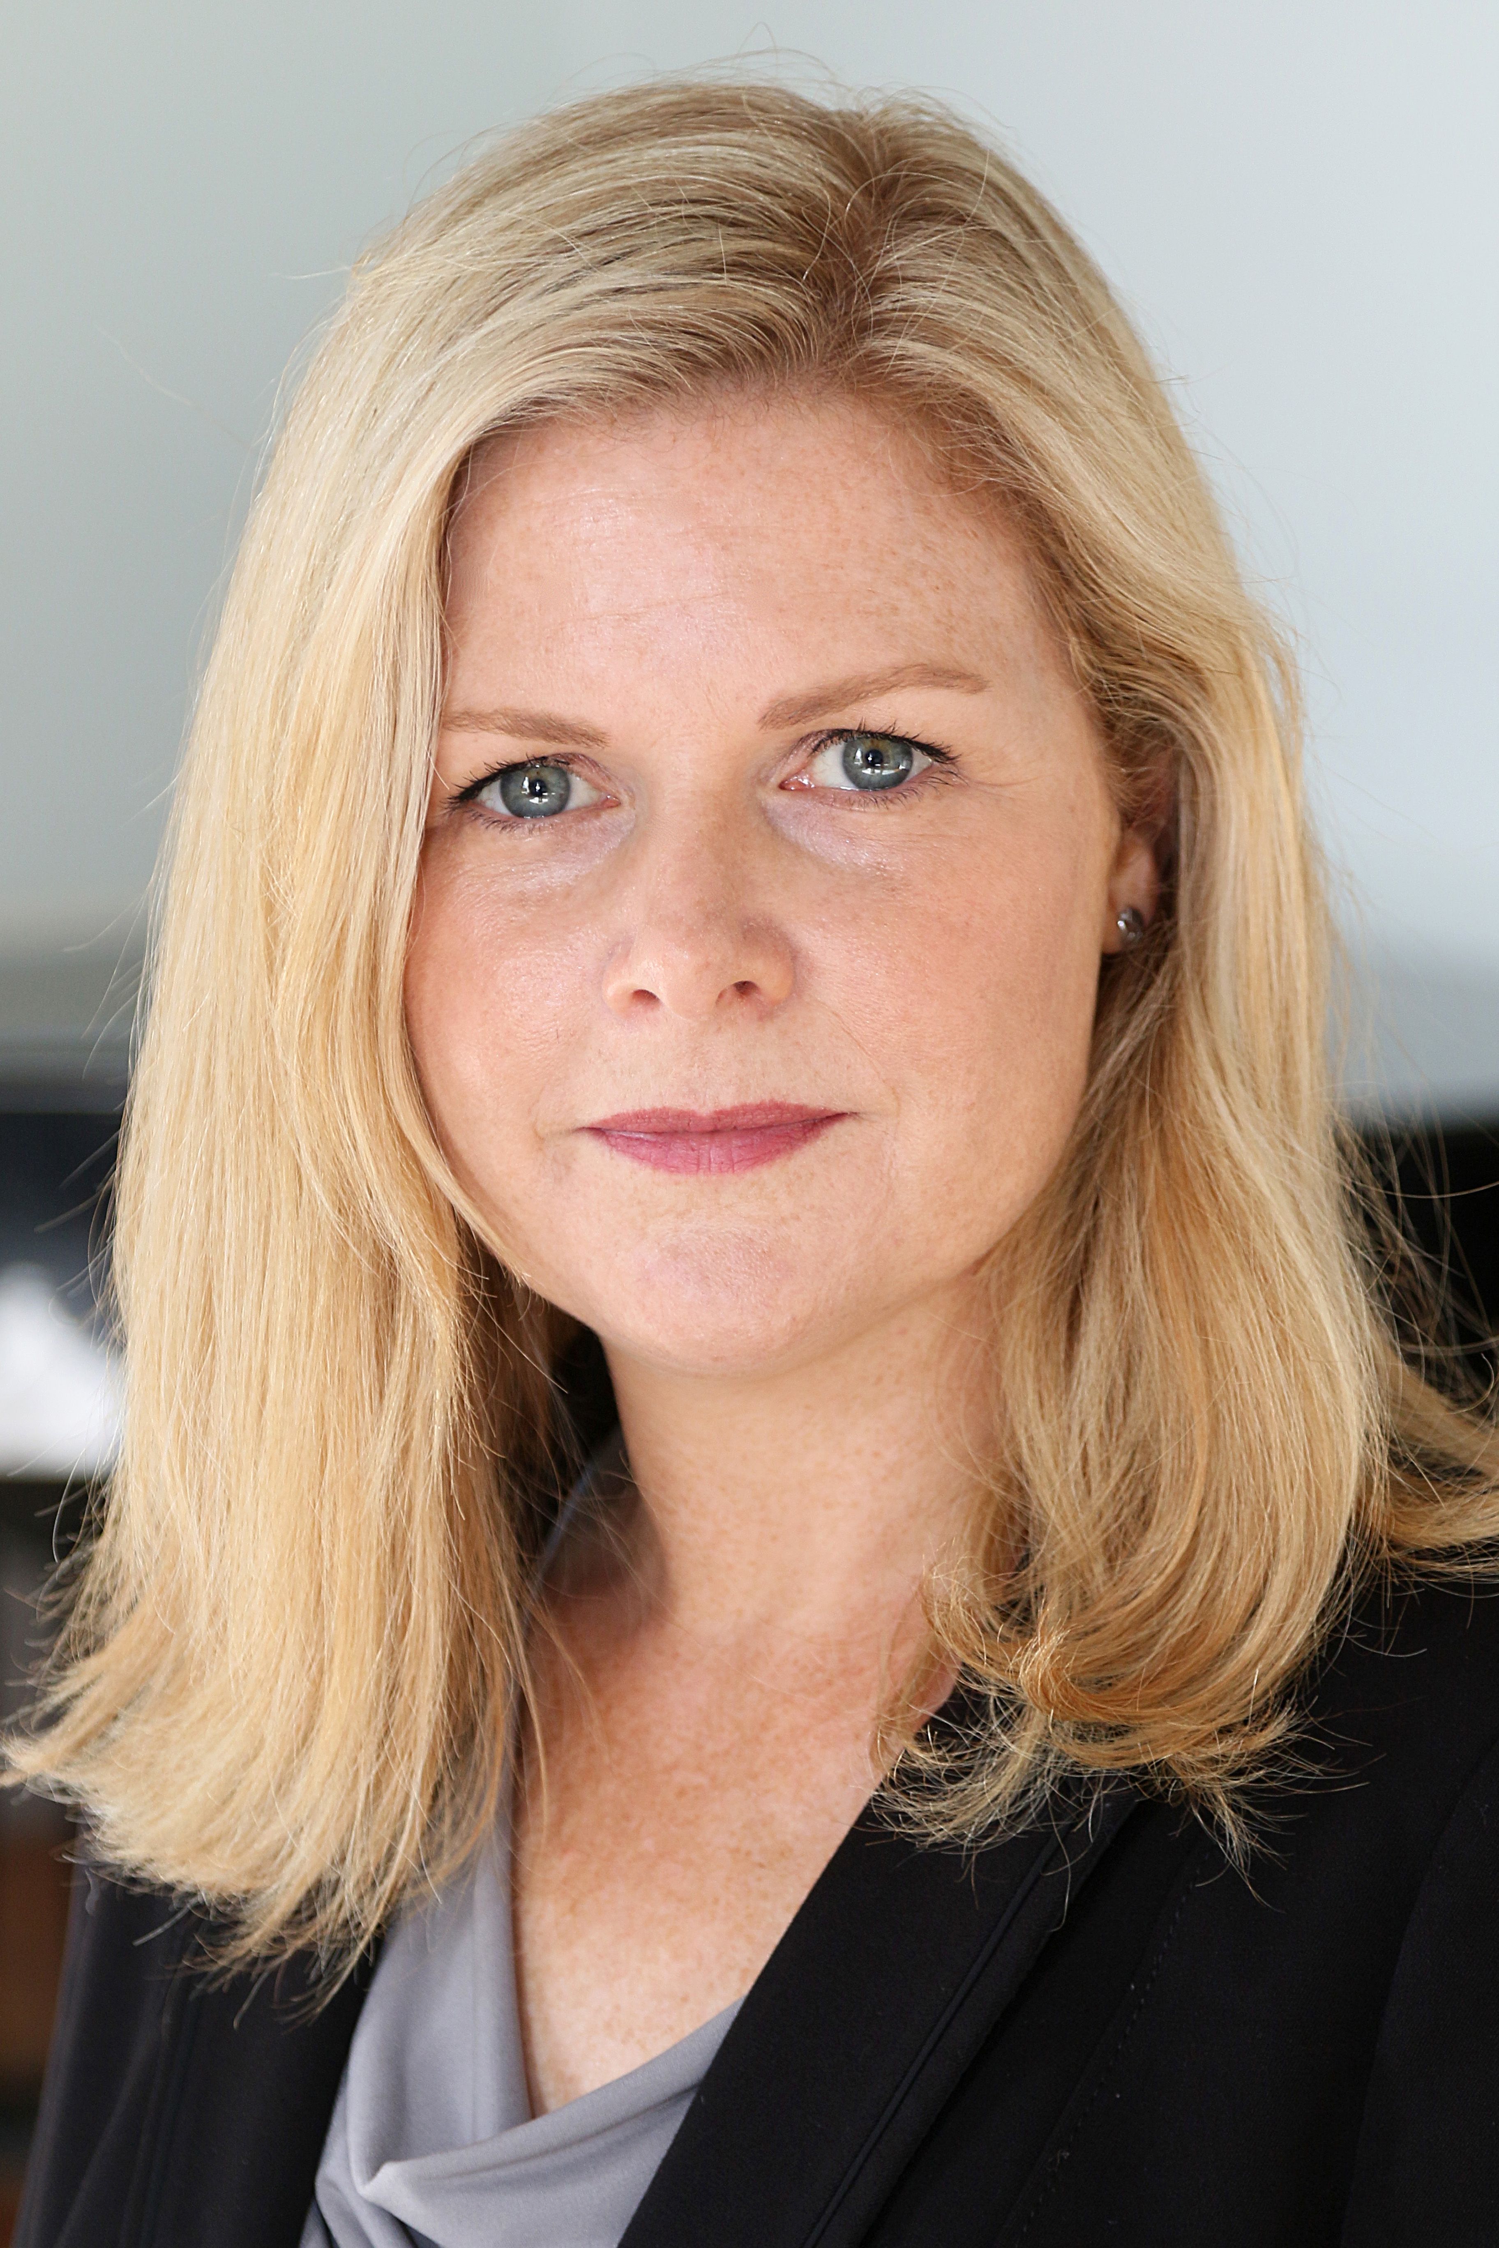

Name | Dr Dara O’Keeffe
Specialty | Surgical Education
Special interest(s) | High Fidelity Simulation; Non-technical skills; Assessment of competence
Affiliated training centre | Royal College of Surgeons in Ireland, Dublin.
Education and training | MB MCh BAO (Medical Doctor), BMedSci, MRCS (Membership in Surgery), Masters in Health Professions Education, Diploma in Healthcare Management.
Hospital Appointment | Non-clinical
Academic Appointment | Senior Lecturer and Simulation Lead in Postgraduate Surgical Education
Society Memberships | - Society for Simulation in Healthcare (SSH)  - SESAM  - Irish Association for Simulation (IAS)  - European Association for Communication in Healthcare (EACH)
Conflict(s) of interest | Consulting:  - None
Research contracts
- No conflicts
Stockholder of a healtchare company
- No
Owner of a healthcare company
- No
Other
- No

