**Programme**

**08.30 Registration with coffee**

**09.00 Welcome:** *Guy Vanderstraeten; Dean UGent - Piet Pattyn; UGent*

**Current status of undergraduate and postgraduate training in Belgium**

Chair: Eric Mortier, CEO UZ Ghent - Isabelle Van Herzeele; UGent

**09.15**UGent Skillslab principles and practice; *Jan Reniers; UGent*

**09.30** UGent Educational Quality Assurance within undergraduate and postgraduate education; *Leen Aper; UGent*

**09.45** *IMEG: Course in echocardiography; Patrick Wouters; UGent*

**10.00** CETRAS: Centre for training and research in anatomical sciences

*Ingrid Kerckaert; UGent*

**10.15** Ghent, the cradle of European Trauma Course

*Lode Blondeel, Defense*

**10.30** *Coffee break*

**11.00 ARB meeting/ITCIT training centre visit**

**12.00 Highlights NASCE annual congress in Istanbul**

*Emin Aksoy, Istanbul, Turkey*

*Anders Bergenfeltz, Lund, Sweden*

**12.15 *Walking lunch***

**Scientific meeting - Multi and interdisciplinary training**

Chair: Patrick Wouters; UGent – Paul Ridgway*, Dublin, Ireland*

**13.15** PROSPECT

(PROficiency-based StePwise Endovascular Curricular Training)

*Heidi Maertens; UGent*

**13.27** Operative hysteroscopy, present and future

*Tjalina Hamerlynck; UGent*

**13.39** On-pump vascular reperfusion of Thiel embalmedcadavers

*Wouter Willaert; UGent*

**13.50 NASCE Executive Meeting** including coffee break

**16.00 End of day**

**NASCE BUSINESS MEETING**

**FEBRUARY 25TH, 2016**

**GHENT UNIVERSITY HOSPITAL**

**BELGIUM**

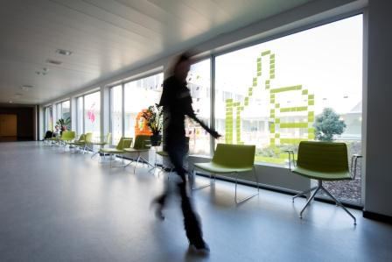

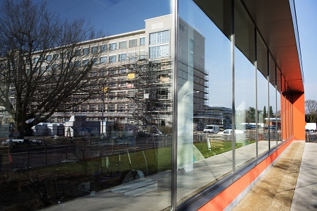

**Venue**

**Ghent University Hospital**

Faculty Room 2K3

De Pintelaan 185

9000 Ghent

Belgium

**For more information &**

**free registration:**

[**inge.vandenbroucke@uzgent.be**](mailto:inge.vandenbroucke@uzgent.be)

**+32/9/332.94.92**

**Accommodation:**

*Holiday Inn Express*: at a 10 min. walking distance from the University Hospital: [www.hiexpress.com/gent](http://www.hiexpress.com/gent)

*B&B Lieven Bauwens*: at +/- 10 min. walking distance from the University Hospital: [www.bblievenbauwens.be/](http://www.bblievenbauwens.be/)

*Marriott Ghent*: In the historical City Centre, transport is required: www.marriottghent.be/

How to get to Ghent: https://visit.gent.be/en/how-get-ghent/

