Summary of NASCE Board or ARB member for the NASCE website

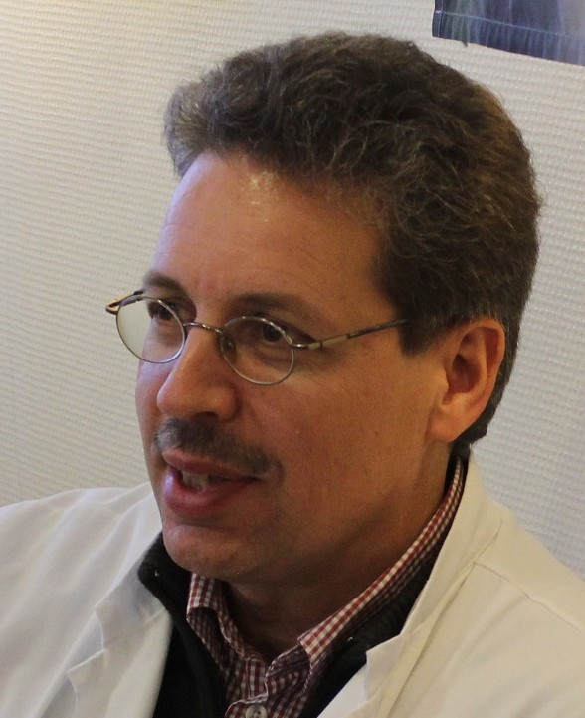

Name | Adjunct Professor Teuvo Antikainen, MD, PhD
Specialty | Surgery
Special interst | General, GI and Pediatric Surgery
Affiliated training centre | Center of Medical Expertise
Education and training | University of Oulu, University of Tampere, Finland
PhD | Yes, 1993
Hospital Appointment | Senior Consultant,  Central Finland Central Hospital
Academic Appointment | Adjunct Professor, University of Jyväskylä, Finland
Society Memberships | - Finnish Medical Association  - Finnish Society of Surgery  - Finnish Medical Society Duodecim  - Association for Medical Education  in Finland
Conflict(s) of interest | Consulting:  - NA
Research contracts
- NA
Stockholder of a healtchare company
- NA
Owner of a healthcare company
- NA
Other
- NA

